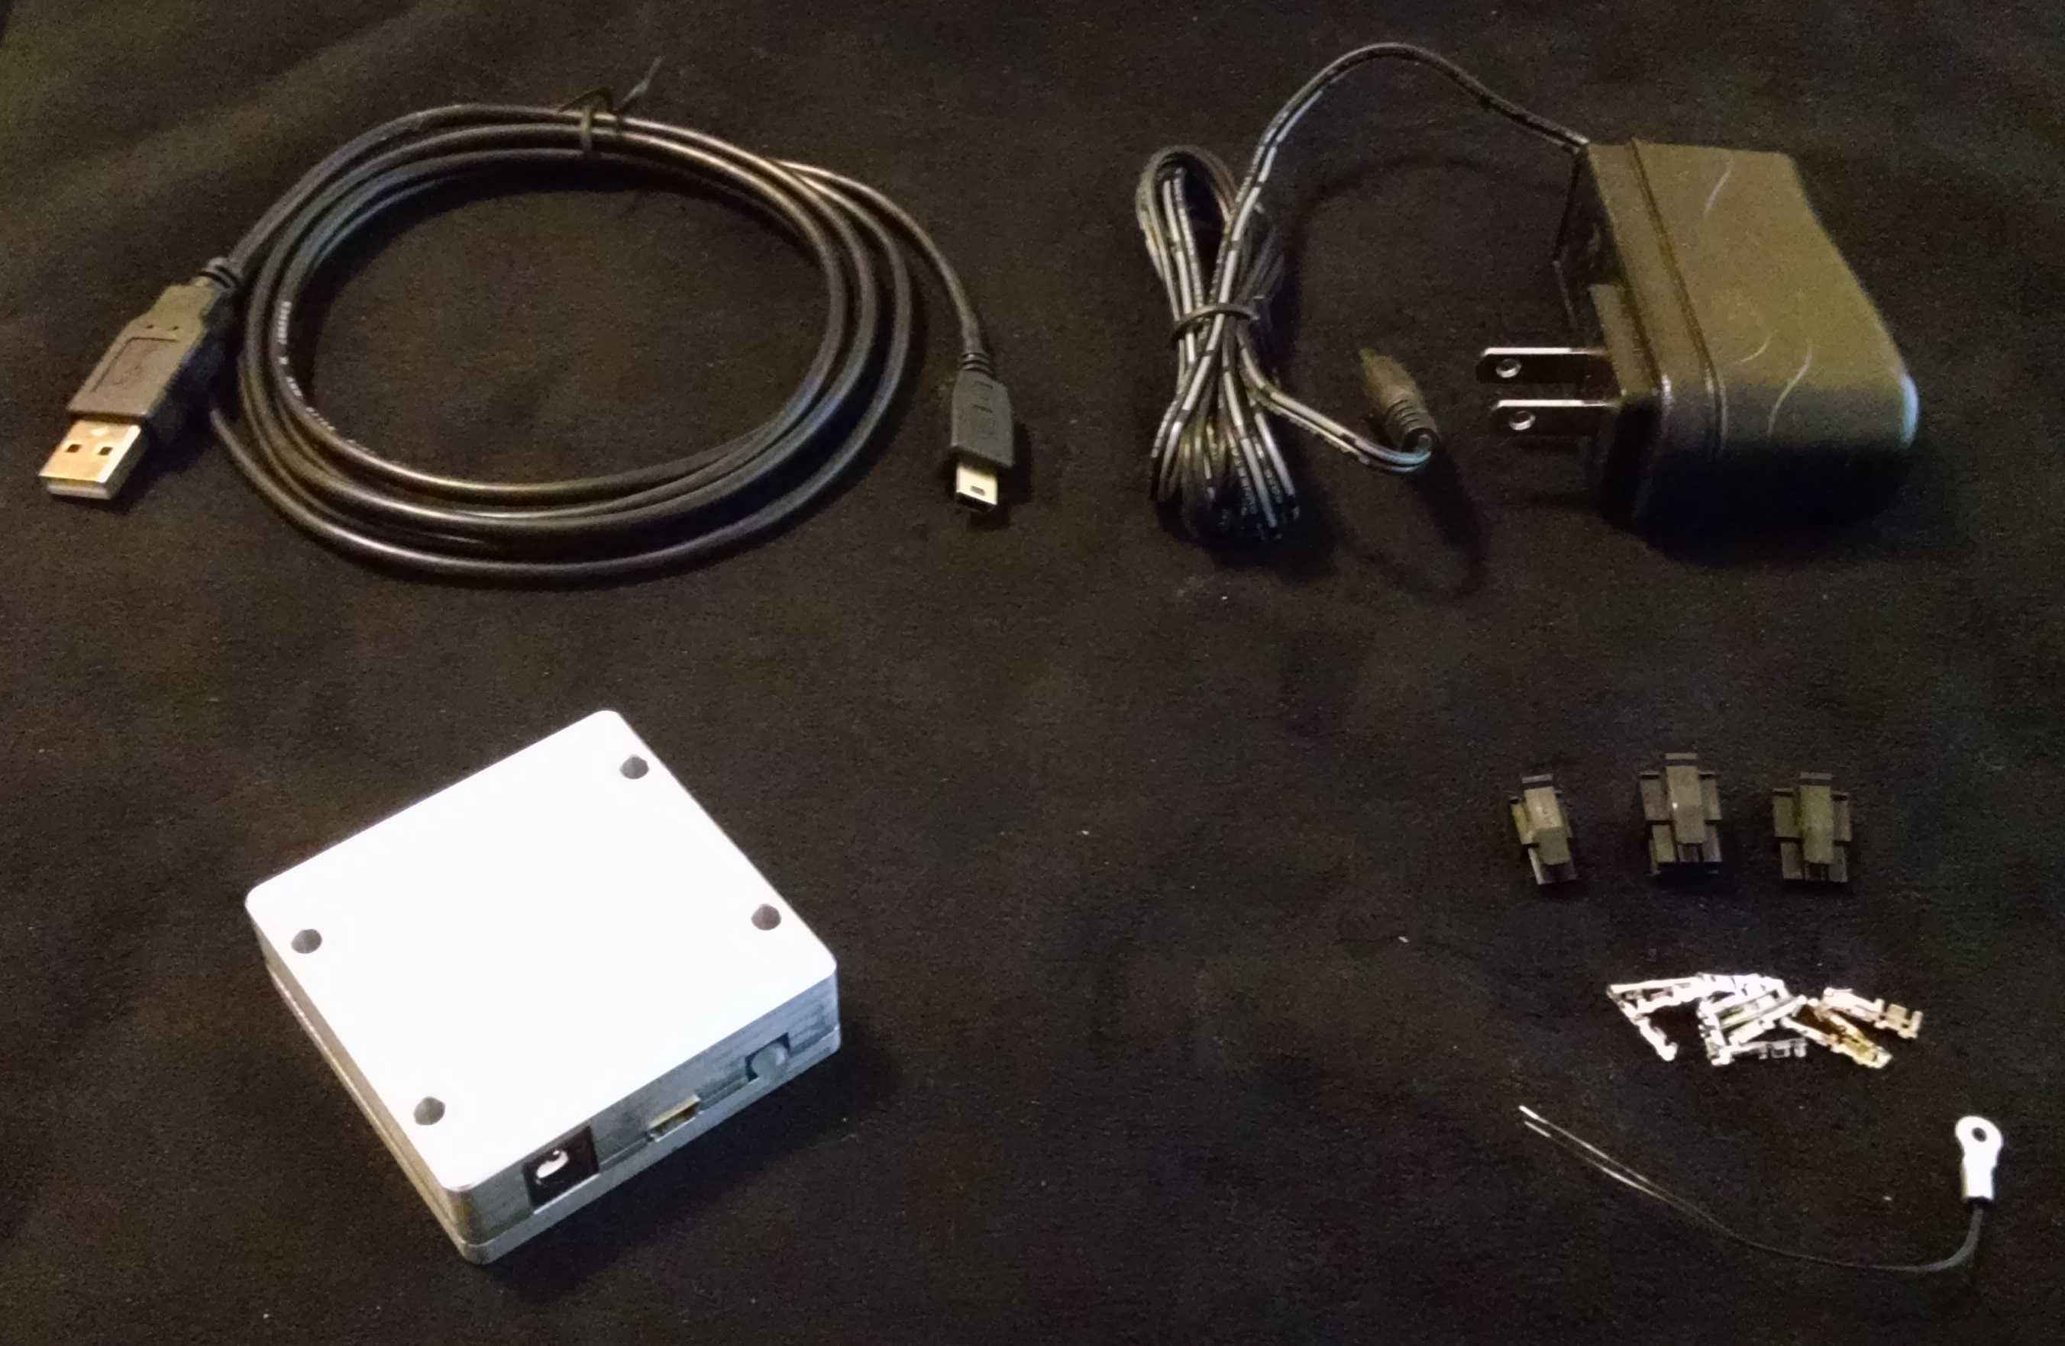
Stellar Focus
Bipolar Stepper Focuser Controller

Table of Contents
1 Inputs and Outputs 3
1.1 Power and Communication 3
1.2 Motor and Sensors 4
1.2.1 Home Switch 4
1.2.2 Motor 4
1.2.3 Temperature Probe 4
1.2.4 Buttons 5
2 ASCOM Integration 6
2.1 Supported Features 6
2.2 Driver Installation 7
2.3 Configuration 8
2.3.1 Configuration Dialog 8
2.3.2 Basic Controls 9
2.3.3 Motor Parameters 9
2.3.4 Homing 10
3 Communication 11
3.1 Driver 11
3.2 Commands 11
3.2.1 Request Position 11
3.2.2 Set Position 12
3.2.3 Halt 12
3.2.4 Enable Temperature Compensation 13
3.2.5 Status 14
3.2.6 Set Motor Parameters 15
3.2.7 Set Zero 16
3.2.8 Home Switch State 16
3.2.9 Set Temporary Velocity Limit 17
3.2.10 Measured Temperature 17
3.2.11 Motion Status 18
3.2.12 Sample Commands 19
4 Dimensions and Mounting 20

Inputs and Outputs

Power and Communication

Power Input
USB
Status Indicator
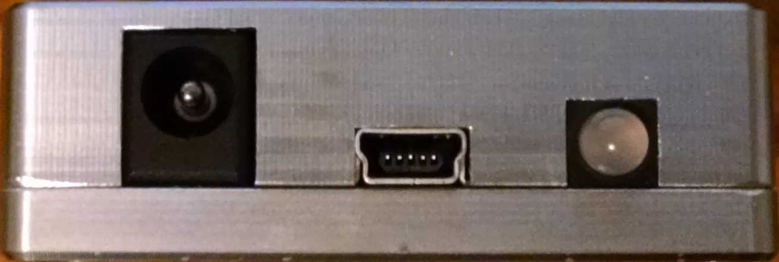Figure 1: Power and communication connections
See Dimensions and Mounting for mating connectors and power supply information. The status indicator flashes red and green for serial receive and transmit indication.

Motor and Sensors

Home Switch
Temperature Probe
Motor
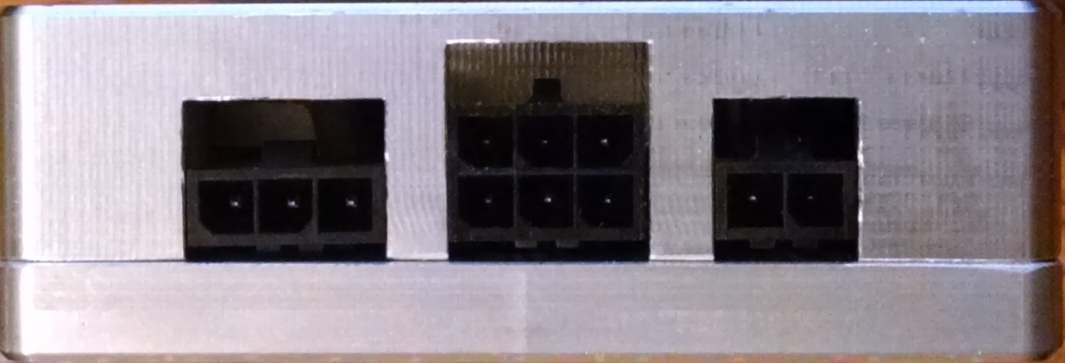Figure 2: Motor and sensor connections
See Dimensions and Mounting for mating connectors and pins.

Home Switch
Pinout, oriented as in Figure 2:
5V Supply | Switch Input | Ground
Table 1: Home switch connector pinout

The 5V supply pin is capable of supplying 100mA of current at 4.5-5V. Switch Input is 5V tolerant and is active high.

Motor
Pinout, oriented as in Figure 2:
Phase A + | +V | Phase B +
Phase A - | +V | Phase B -
Table 2: Motor connector pinout

Phase A and B connect to bipolar motor phases with the specified polarity. +V provides access to the motor supply power rail and is unused in the bipolar configuration.

Temperature Probe
Pinout, oriented as in Figure 2:
Temperature Probe Sense | Ground
Table 3: Temperature probe connector pinout

This port is calibrated to have a 10kΩ NTC thermistor connected across the pins.

Buttons

Move +
Move -
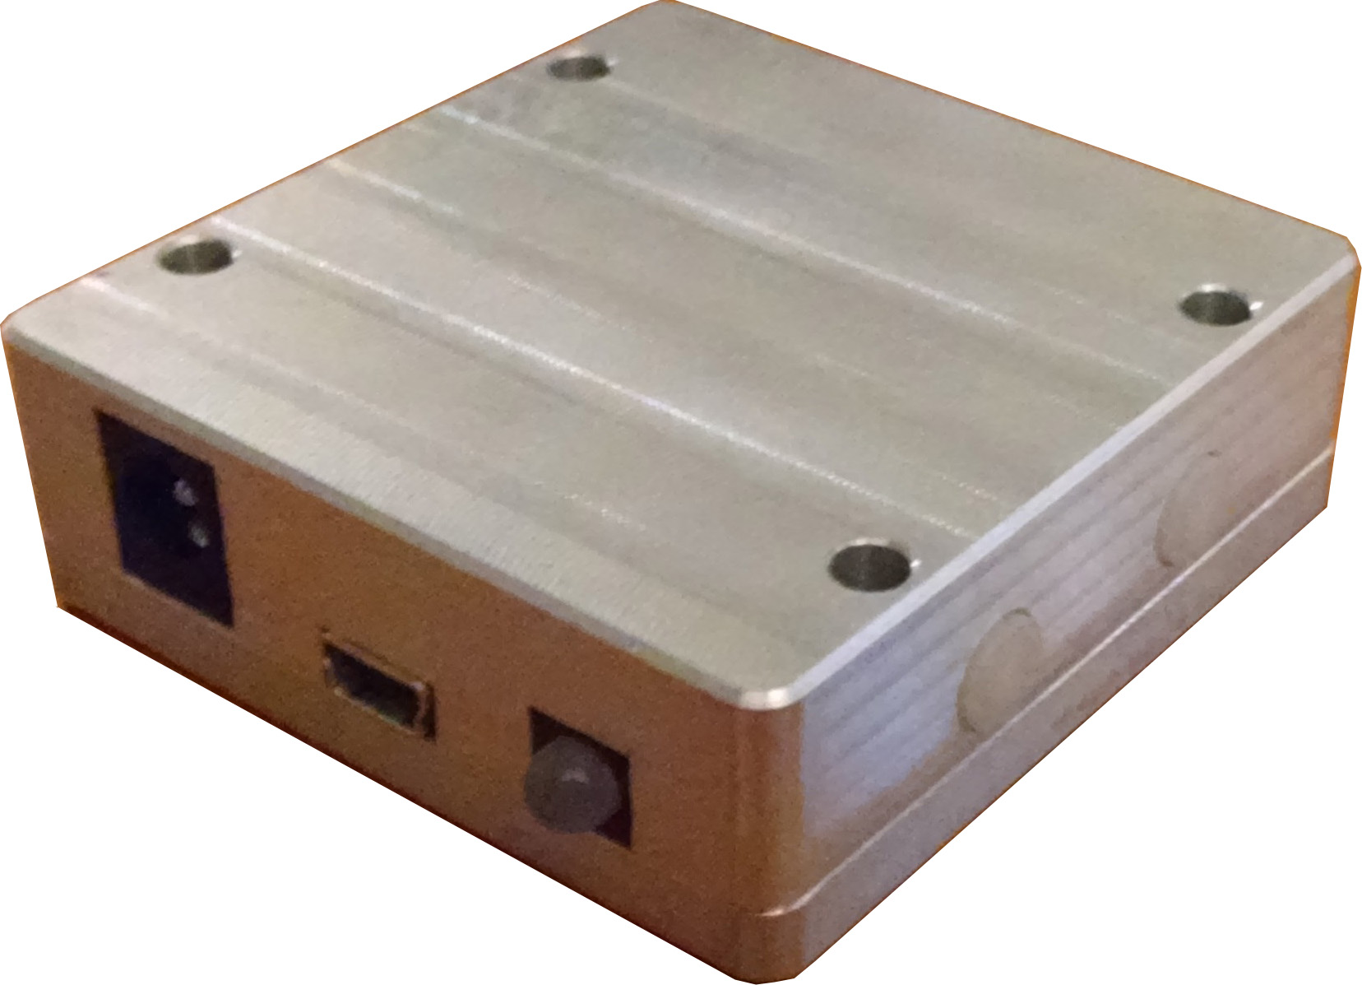Figure 3: Button functions
When pushed quickly, these buttons result in a movement of one step in the indicated direction. When held, they result in continuous motor movement in the indicated direction. Releasing a button while the motor is in motion results in the motor slowing, stopping, and returning to the position that was recorded at the instant the button was released. The Reverse setting in the ASCOM driver's configuration window has no effect on the direction of these buttons.

ASCOM Integration

Supported Features
The controller and ASCOM driver support the following features of ASCOM platform 6.3's Focuser V2 interface.

Methods
Action | Unsupported
CommandBlind | Unsupported
CommandBool | Unsupported
CommandString | Unsupported
Dispose | Supported
Halt | Supported. Will latch the current position when this command is received and returns to it after safely decelerating, if necessary.
Move | Supported.
SetupDialog | Supported. Displays the configuration dialog box.
Table 4: Supported ASCOM methods

Properties
Absolute | Always returns true.
Connected | Supported. Will home on connection if configured to in the configuration dialog box.
Description | Supported
DriverInfo | Supported
DriverVersion | Supported
InterfaceVersion | Supports interface version 2.
IsMoving | Supported
Link | Supported
MaxIncrement | Returns 65535.
MaxStep | Returns 65535.
Name | Supported
Position | Supported
StepSize | Unsupported
SupportedActions | Returns an empty list since actions are unsupported
TempComp | Supported
TempCompAvailable | Always returns true.
Temperature | Supported. Returns the temperature of the connected. Throws an exception if there's an issue with the sensor.
Table 5: Supported ASCOM properties

Driver Installation
To install the ASCOM driver, simply run the driver setup file. The most current version is named “Stellar Focus Setup.exe” and can be obtained by visiting https://github.com/bdm310/StellarFocus_Driver .

Configuration

Configuration Dialog
All configuration is done through the ASCOM driver's setup dialog box. To access it, follow this process:
- Open ASCOM Diagnostics.
- Click on Choose Device and select the appropriate Choose and Connect to Device.
- Change the Device Type to Focuser and click on Choose.
- Pick Focuser Driver for StellarFocus from the drop down list.
- Click on Properties to bring up the configuration window.
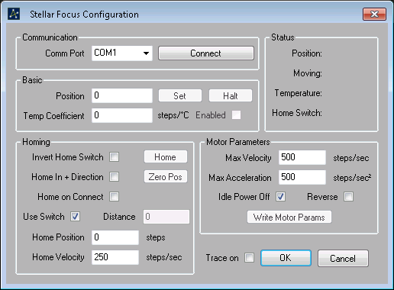Figure 4: Configuration Window

All settings on this page are saved to the computer when Ok is clicked. Nothing is saved if Cancel is clicked instead. The Trace check box enables ASCOM logging.

Basic Controls
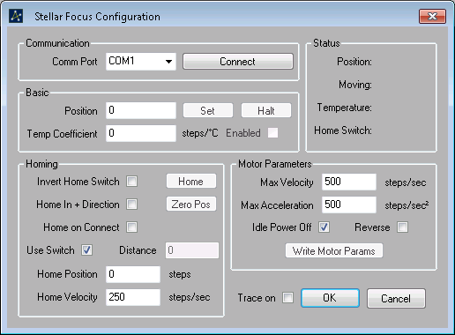Figure 5: Basic controls

The Comm Port drop down list allows for selection of the controller's serial port from the available ports on the system. Pressing Connect will attempt to connect to a controller on that port. If successful, the same button allows for disconnection. While connected, the status frame provides continuously updated information about the controller's status. The Basic frame provides a way to command a position, halt movement, set a temperature compensation coefficient, and enable or disable temperature compensation.

Motor Parameters
Figure 6: Motor parameters
This frame provides access to motor specific parameters. Max Velocity, Max Acceleration, and Idle Power Off are stored on the controller in addition to on the computer. The controller values are only updated when Write Motor Parameters is pressed. These parameters are also loaded from the controller upon connection. Reverse simply reverses the direction of movement.

Homing
Figure 7: Homing
The Homing frame provides control of the homing parameters. There are two different homing processes; one in which the controller simply moves a number of steps in the specified direction in order to force the motor against a mechanical stop and a second in which a homing switch is used to find a reference position. When Home In + Direction is checked, the first stage of each process begins by moving the motor in the positive direction. If it is not checked, the motor moves in the negative direction.
The first homing process simply moves at Home Velocity speed for Distance steps in the direction set by Home In + Direction.
The second homing process has three parts. First, the controller will move at the Home Velocity in the direction set by Home In + Direction until the switch state becomes True. Second, the controller will stop and move in the opposite direction at half of Home Velocity until the switch state becomes False. Third, the controller will step in the original direction until the switch state becomes True again. This process enables switch and motor backlash compensation as well as a short time to home.
Once either homing process is complete, the controller's position is set such that the current position becomes Home Position.
If home on connect is checked, the driver will home the motor whenever it is connected to.

Communication

Driver
Versions of Microsoft Windows Vista and later, Linux kernels 2.6.39 and later, and Mac OS 10.9 (Mavericks) and later should automatically find and install the correct drivers. For operating systems that do not, visit http://www.ftdichip.com/Drivers/VCP.htm and select the appropriate installation package for your operating system and computer architecture.

Commands
The controller accepts and responds to commands over a 115200 baud full duplex serial link with odd parity and 8 data bits. When sending a command to the controller, the first byte is a header with its lower nibble containing the command number and the upper nibble containing the total number of data bytes to be transmitted. For example, sending command number 0x06 with four data bytes would result in the first byte of the packet being 0x46. Multi-byte values follow the little endian ordering scheme.

Request Position
 | Command | 1
 | Data Bytes | 0
Table 6: Request position command

 | Command | 1
 | Data Bytes | 2
Starting Data Byte Number | Data Type | Description
0 | Signed 16 bit integer | Motor Position
Table 7: Request position response

Motor Position describes the current position of the motor in units of steps.

Set Position
 | Command | 2
 | Data Bytes | 2
Starting Data Byte Number | Data Type | Description
0 | Signed 16 bit integer | Desired Motor Position
Table 8: Set position command

 | Command | 2
 | Data Bytes | 2
Starting Data Byte Number | Data Type | Description
0 | Signed 16 bit integer | Set Motor Position
Table 9: Set position response

Desired Motor Position describes the position to move the motor to in units of steps. Desired Motor Position is echoed back in Set Motor Position for verification.

Halt
 | Command | 3
 | Data Bytes | 0
Table 10: Halt command

 | Command | 3
 | Data Bytes | 0
Table 11: Halt response

The controller will latch the position at the instant this command is received and will return to it after decelerating the motor safely. This position then becomes the desired position.

Enable Temperature Compensation
 | Command | 4
 | Data Bytes | 2
Starting Data Byte Number | Data Type | Description
0 | Signed 16 bit integer | Desired Temperature Coefficient
Table 12: Enable temperature compensation command

 | Command | 4
 | Data Bytes | 2
Starting Data Byte Number | Data Type | Description
0 | Signed 16 bit integer | Set Temperature Coefficient
Table 13: Enable temperature compensation response

Desired Temperature Coefficient describes the position to move the motor to in units of . Desired Temperature Coefficient is echoed back in Set Temperature Coefficient for verification. Temperature compensation is disabled by setting this coefficient to zero. This coefficient is not stored on the controller and will be lost on a power cycle.

Status
 | Command | 5
 | Data Bytes | 0
Table 14: Status command

 | Command | 5
 | Data Bytes | 6
Starting Data Byte Number | Data Type | Description
0 | Signed 16 bit integer | Temperature Coefficient
2 | Unsigned 8 bit integer | Idle Off
3 | Unsigned 8 bit integer | Maximum Acceleration
4 | Signed 16 bit integer | Maximum Velocity
Table 15: Status response

Temperature Coefficient is the currently programmed temperature compensation coefficient and is non-zero is temperature compensation is currently active. Idle Off is non-zero if the controller is configured to turn the motor drivers off after a period of inactivity. Maximum Acceleration represents the current maximum acceleration rate in units of . Maximum Velocity is a representation of the current maximum velocity in units of .

Set Motor Parameters
 | Command | 6
 | Data Bytes | 4
Starting Data Byte Number | Data Type | Description
0 | Unsigned 16 bit integer | Desired Maximum Velocity
2 | Unsigned 8 bit integer | Desired Maximum Acceleration
3 | Unsigned 8 bit integer | Desired Idle Off
Table 16: Set motor parameters command

 | Command | 6
 | Data Bytes | 4
Starting Data Byte Number | Data Type | Description
0 | Unsigned 16 bit integer | Desired Maximum Velocity
2 | Unsigned 8 bit integer | Desired Maximum Acceleration
3 | Unsigned 8 bit integer | Desired Idle Off
Table 17: Set motor parameters response

Desired Maximum Velocity represents of the desired maximum motor velocity in units of . The maximum velocity value is limited to 2000. Desired Maximum Acceleration represents the desired maximum acceleration rate in units of . The maximum acceleration is limited to 127, or 12700. Desired Idle Off is non-zero to configure the controller to turn the motor drivers off after a period of inactivity. The controller will respond with all of the received values for verification.

Set Zero
 | Command | 2
 | Data Bytes | 2
Starting Data Byte Number | Data Type | Description
0 | Signed 16 bit integer | Desired Zero Position
Table 18: Set zero command

 | Command | 2
 | Data Bytes | 2
Starting Data Byte Number | Data Type | Description
0 | Signed 16 bit integer | Set Zero Position
Table 19: Set zero response

The controller will reset the motor position and position set point values to the value in Desired Zero Position.

Home Switch State
 | Command | 8
 | Data Bytes | 0
Table 20: Home switch state command

 | Command | 8
 | Data Bytes | 1
Starting Data Byte Number | Data Type | Description
0 | Unsigned 8 bit integer | Switch State
Table 21: Home switch state response

The controller will return the state of the home switch pin; 1 for a high level and 0 for a low level.

Set Temporary Velocity Limit
 | Command | 9
 | Data Bytes | 2
Starting Data Byte Number | Data Type | Description
0 | Unsigned 16 bit integer | Desired Velocity Limit
Table 22: Set temporary velocity command

 | Command | 9
 | Data Bytes | 2
Starting Data Byte Number | Data Type | Description
0 | Unsigned 16 bit integer | Set Velocity Limit
Table 23: Set temporary velocity response

Sets a temporary velocity limit in units of . This limit is not persistent and will be lost on a power cycle.

Measured Temperature
 | Command | 10
 | Data Bytes | 0
Table 24: Measured temperature command

 | Command | 10
 | Data Bytes | 2
Starting Data Byte Number | Data Type | Description
0 | Unsigned 16 bit integer | Measured Temperature
Table 25: Measured temperature response

Measured Temperature contains the temperature of an attached probe with units of .

Motion Status
 | Command | 11
 | Data Bytes | 0
Table 26: Motion status command

 | Command | 11
 | Data Bytes | 1
Starting Data Byte Number | Data Type | Description
0 | Unsigned 8 bit integer | Motion Status
Table 27: Motion status response

Motion Status is non-zero if the motor is currently in motion.

Sample Commands
Sample command sequence to set the velocity limit to 418, the acceleration limit to 200 and to enable the idle power down with command 6:
Value | 0x4 | 6 | 0xA2 | 0x01 | 0x02 | 0x01
Byte Number | 0 |  | 1 | 2 | 3 | 4
Data Byte | - |  | 0 | 1 | 2 | 3
Description | Data Bytes | Command | Velocity |  | Accel | IdleOff
Table 28: Sample velocity limit command

The response will be the same as the command and should be verified to ensure correct reception of the command.

Sample command sequence to request the current position with command 1:
Value | 0x0 | 1
Byte Number | 0
Data Byte | -
Description | Data Bytes | Command
Table 29: Sample position request command

Response to the above command showing a position of 1540 steps:
Value | 0x3 | 1 | 0x04 | 0x06
Byte Number | 0 |  | 1 | 2
Data Byte | - |  | 0 | 1
Description | Data Bytes | Command | Motor Position
Table 30: Sample position request response

Dimensions and Mounting
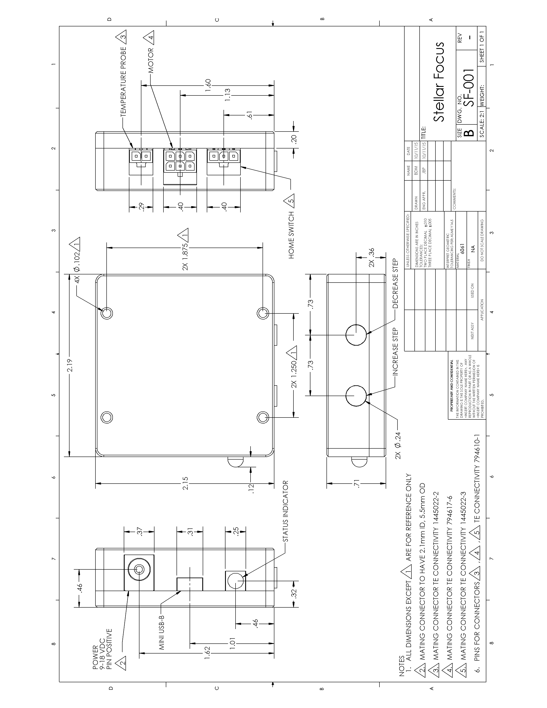Figure 8: Dimensions and mounting

